Working together towards 100% certified sourcing by 2027
In recent years, DFG has voluntarily worked towards 90% certified sourcing of flowers and plants, in line with FSI guidelines. In 2024, we reached 77% together, and we expect to reach around 85% in 2025. Starting in 2025, we are taking a new step: through a clear roadmap, we are working towards 100% certified sourcing by 1 July 2027.
This memo explains:
- Why certification is important
- Why DFG aims for 100% certified sourcing
- What the roadmap entails
- What this means for you and your company
- Practical tips for achieving results (quickly)

Please note: this is no longer a non-binding ambition. It is a necessary and mandatory step to ensure DFG’s future readiness.
Why is certification important?
Requirements from legislation (such as CSRD and CSDDD), our customers, end users/consumers, and the media are becoming increasingly strict. There is a growing demand for assurance regarding safe and responsible production. DFG also finds it important to gain insights into data and working conditions within our supply chain and to report transparently on these aspects.
Certification provides access to the necessary insights and data. It also ensures that fundamental risks are covered and helps us, as a group of companies, and as an ornamental horticulture sector, to protect the image of our products.
In short: certification is not a goal in itself, but a means to achieve transparency, risk management, and a stronger reputation for our sector.
Why does DFG want 100% certified sourcing?
Think of it as a driver’s license for growers. Even if you grow high-quality products, a certificate proves that you meet requirements in terms of the environment, working conditions, and safety. Independent verification builds trust—just like a driving test.
With certification:
- We reduce risks for DFG and our customers
- We can comply with legislation
- We proactively address questions from public opinion and the media
- We strengthen our position with customers, stakeholders, and as an employer

What is the roadmap?
To move towards 100%, a roadmap was created in March 2024 in collaboration with Royal FloraHolland, FM Group, Royal Lemkes, Van der Plas Group, and VGB. It outlines clear steps and deadlines through to 2027.
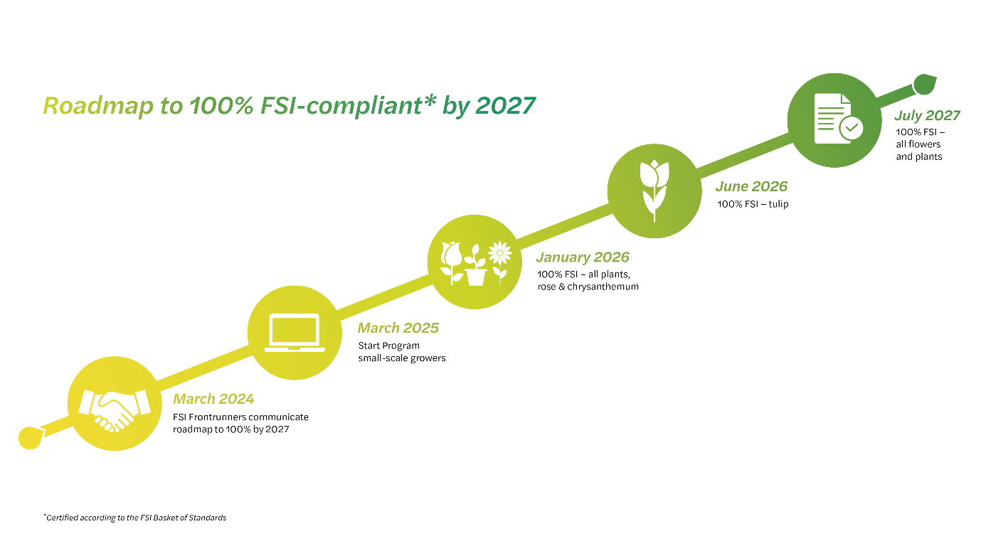
What is expected of you?
Every company within DFG plays a role in achieving our goals. If one company fails to meet the requirements, it poses a risk to the entire group.
Starting from 1 January 2026, every company is expected to source according to the 100% requirement for the applicable product groups at that time, and to work towards the deadlines for the remaining products.
In concrete terms:
- Align your processes with 100% certified sourcing
- Engage in discussions with buyers, sellers, suppliers, and customers
- Share bottlenecks and successes with DFG—we learn from each other
How can you accelerate? Best practices from the field
Since 2017, we’ve learned a lot. Here’s what works:
- Appoint an internal lead for certified sourcing
- Develop a concrete action plan involving all relevant departments
- Monitor your progress monthly using the Floridata Sustainable Sourcing Scan and adjust as needed
- Start with your highest volumes
- Make agreements with your buyers and incorporate these into personal objectives
- Keep regular (weekly) contact with your top 50/100/200 uncertified growers. We see companies having more and faster success with this approach
Support from DFG
DFG offers support by sharing information and connecting companies with each other. Several companies have already developed complete sourcing training programmes or implemented systems within their Certifeye or ERP—others can benefit from these examples. Issues around data, intermediaries, database errors, etc., have often already occurred elsewhere and been resolved.
What comes next?
The current focus is on flowers and plants, but the scope will expand. In the future, packaging, hardware, consumables, and contracted labour will also fall under certification requirements. Start preparing now.
More information:
- Information FSI:
  - General: https://www.fsi2025.com/
  - Required certifications: https://www.fsi2025.com/basket/
- Small scale growers program:
  - https://my-mps.com/diensten/mps-compact/
  - https://www.royalfloraholland.com/over-ons/duurzaamheid/duurzaamheidscertificering/kleinschalige-kwekerschema
- Royal Flora Holland:
  - https://www.royalfloraholland.com/over-ons/duurzaamheid/duurzaamheidscertificering
  - https://www.royalfloraholland.com/service-en-contact/duurzaamheid

